Danait Teklemariam

ITIS - 6120-052

Project - II

1. Create an application programming interface (API) using stored procedures

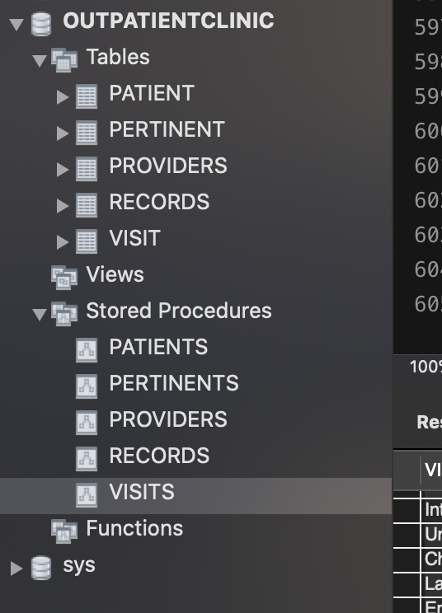

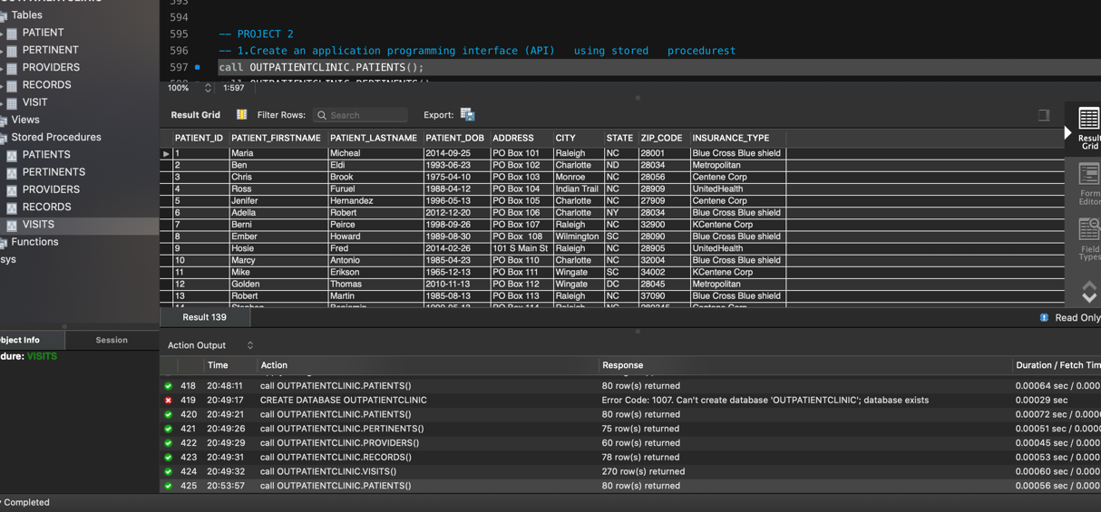

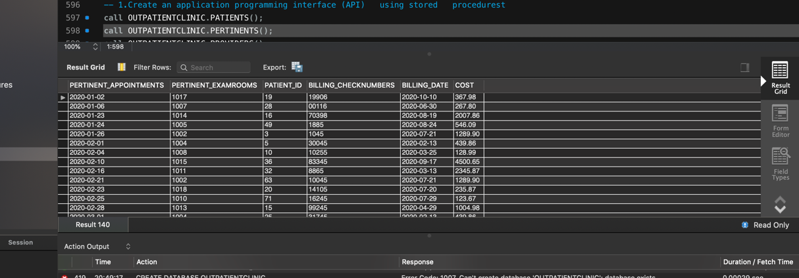

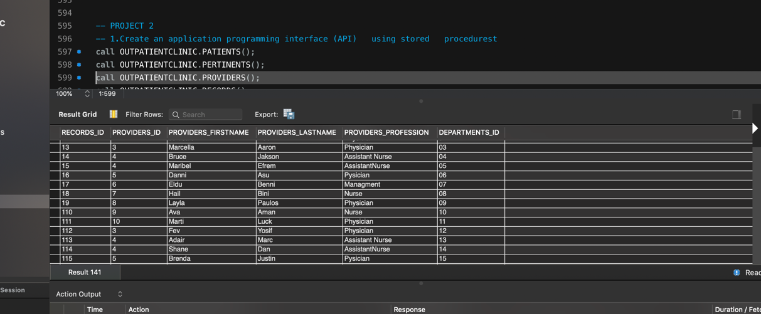  
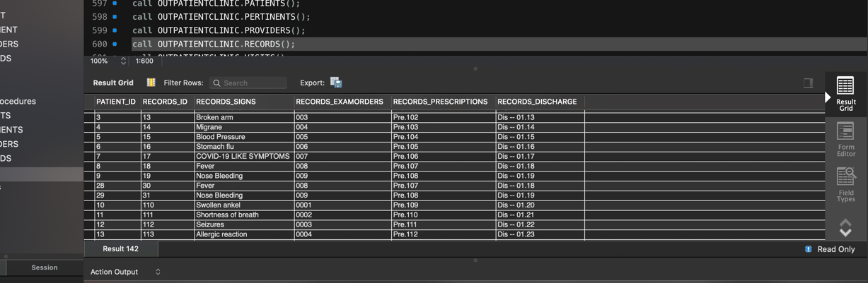

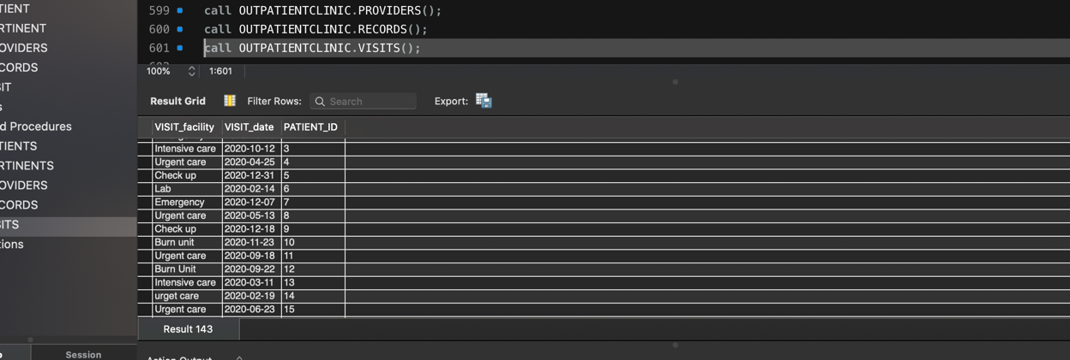

2. Add user authentication so that only authorized users can access the database

* Checking grant for

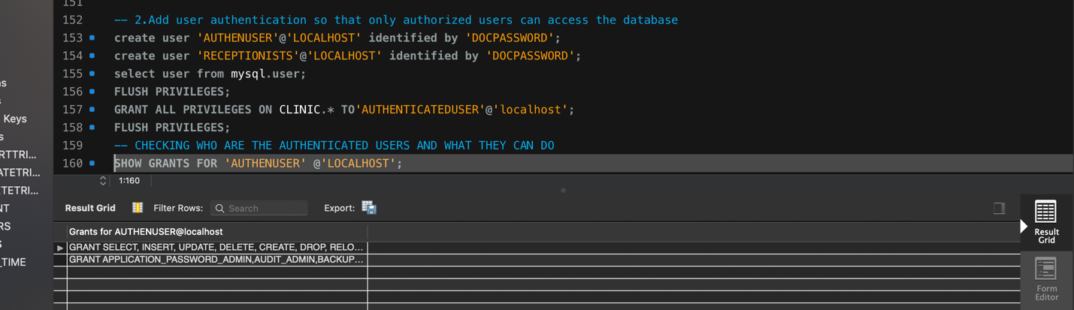

3. Add some form of role-based access control to limit the functions that a user can perform.

* Checking role for Doctors

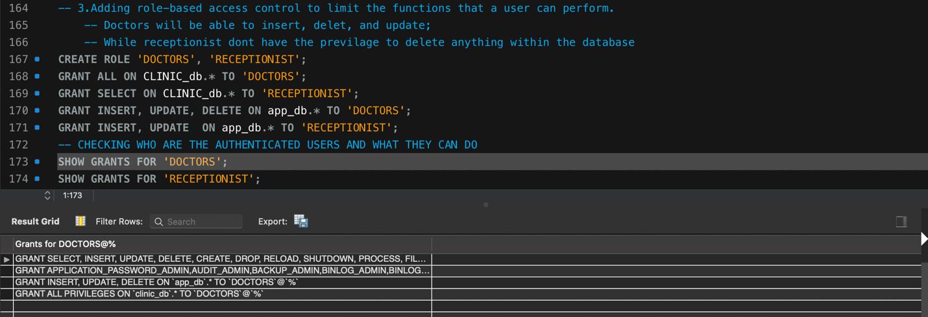

* Checking role for receptionist

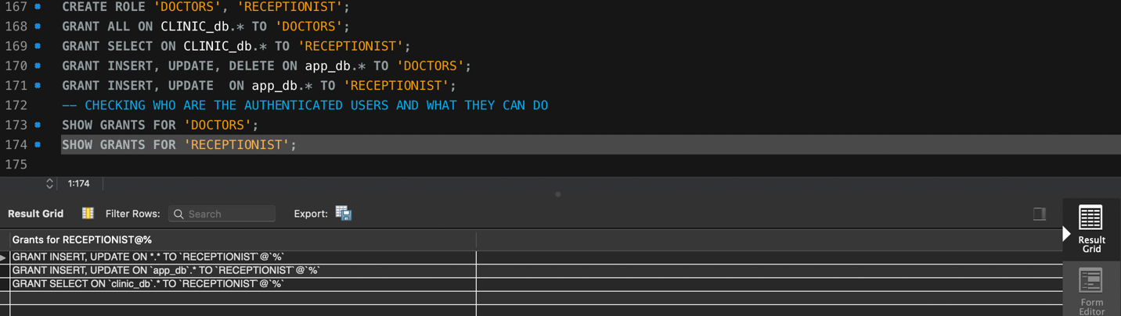

4. Add tables and other features to enable audit trail so that every query or change of every record in the database is monitored and the entire history of the data in the database is captured.

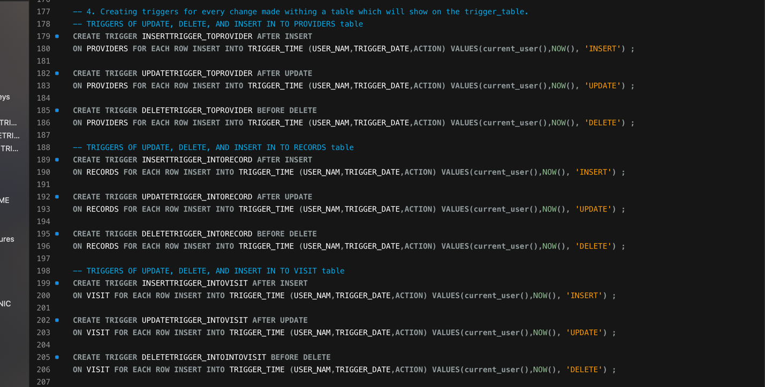

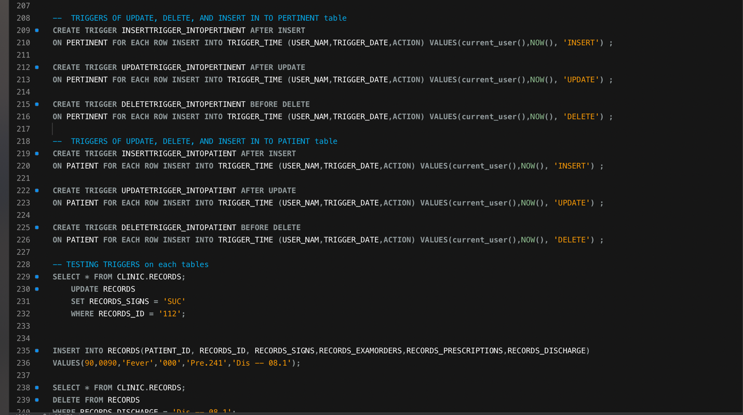

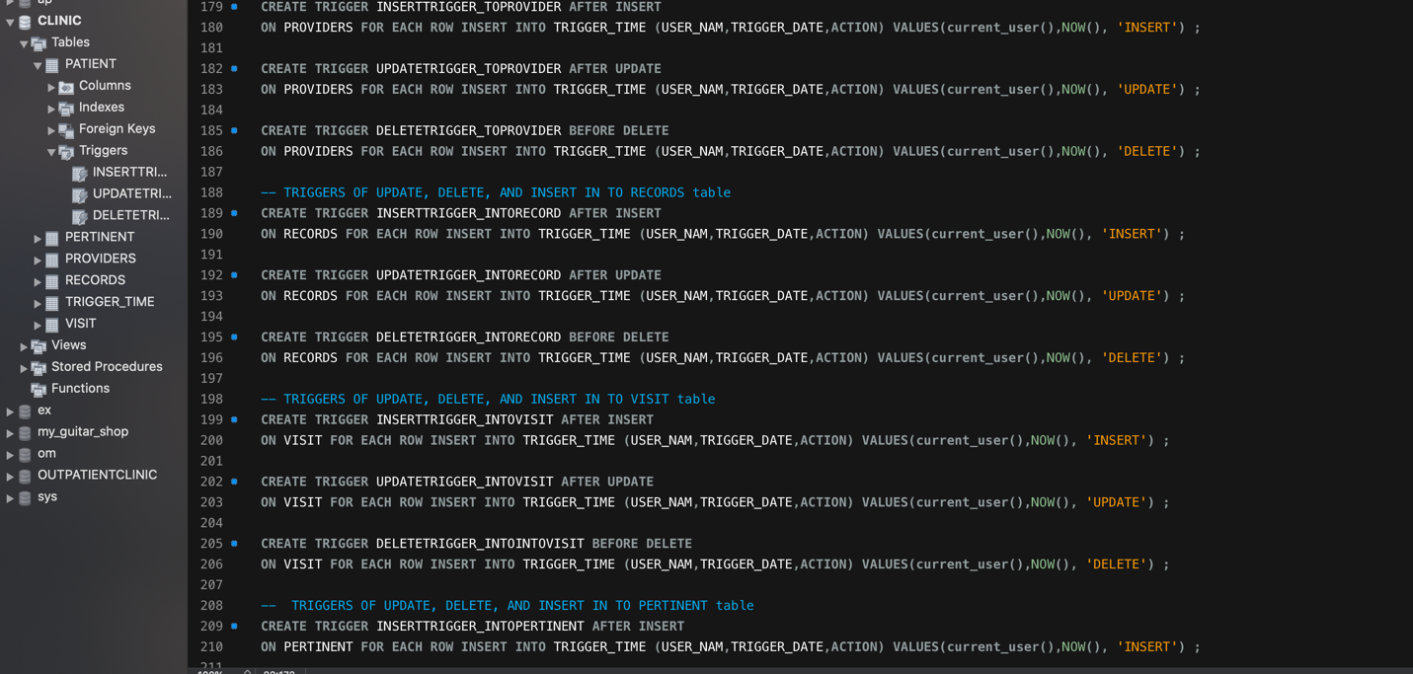

5. Add indexes and views so that frequently used queries and changes to the database are most efficient.

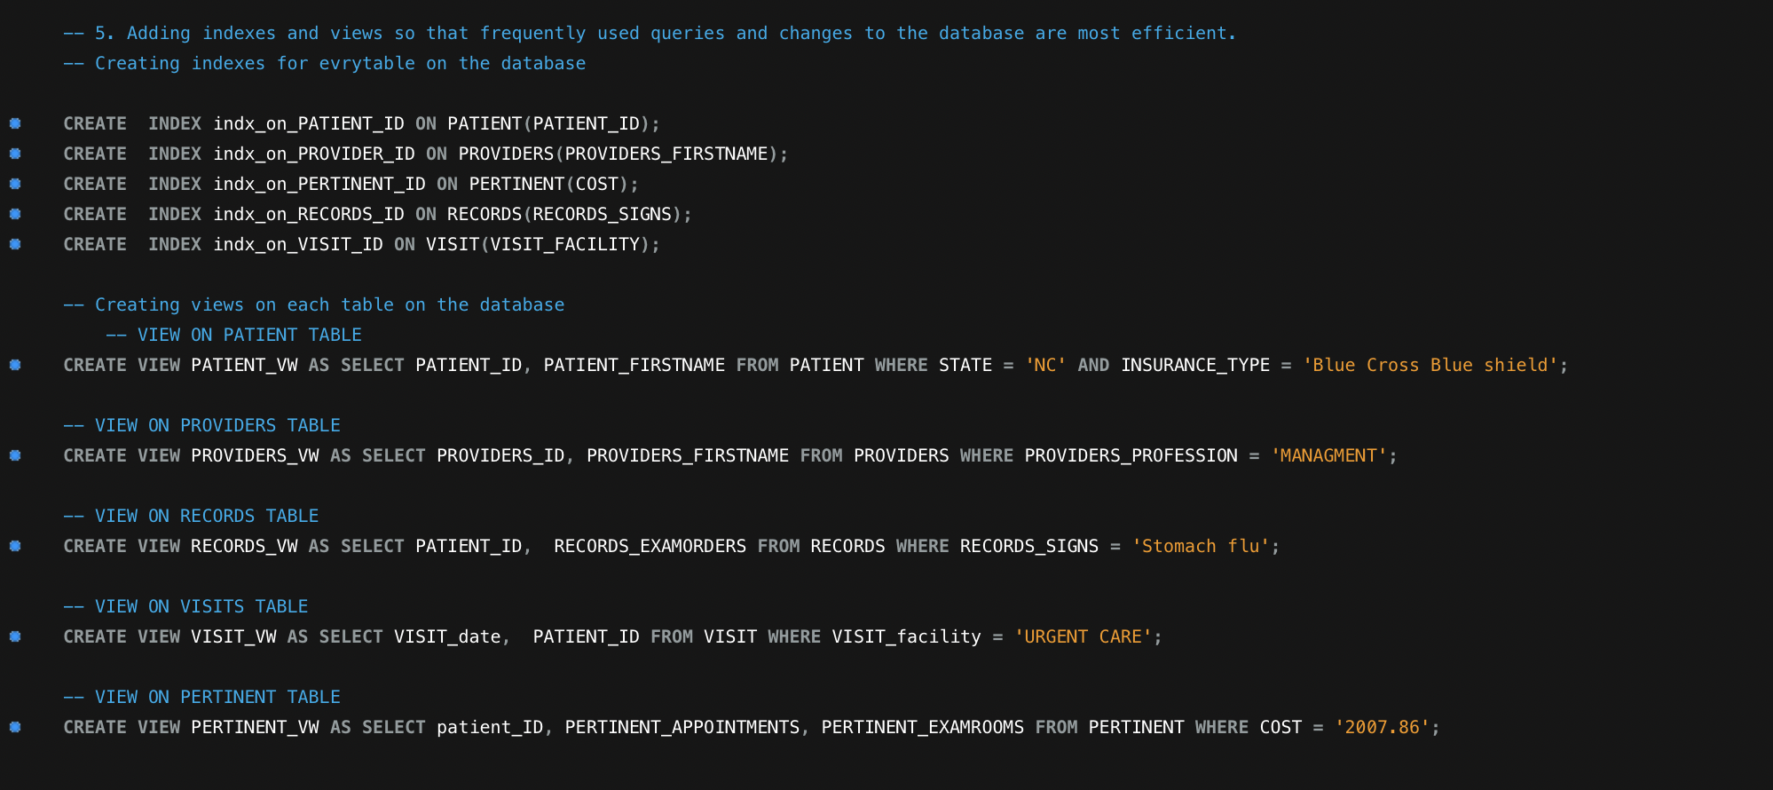

* ER diagram

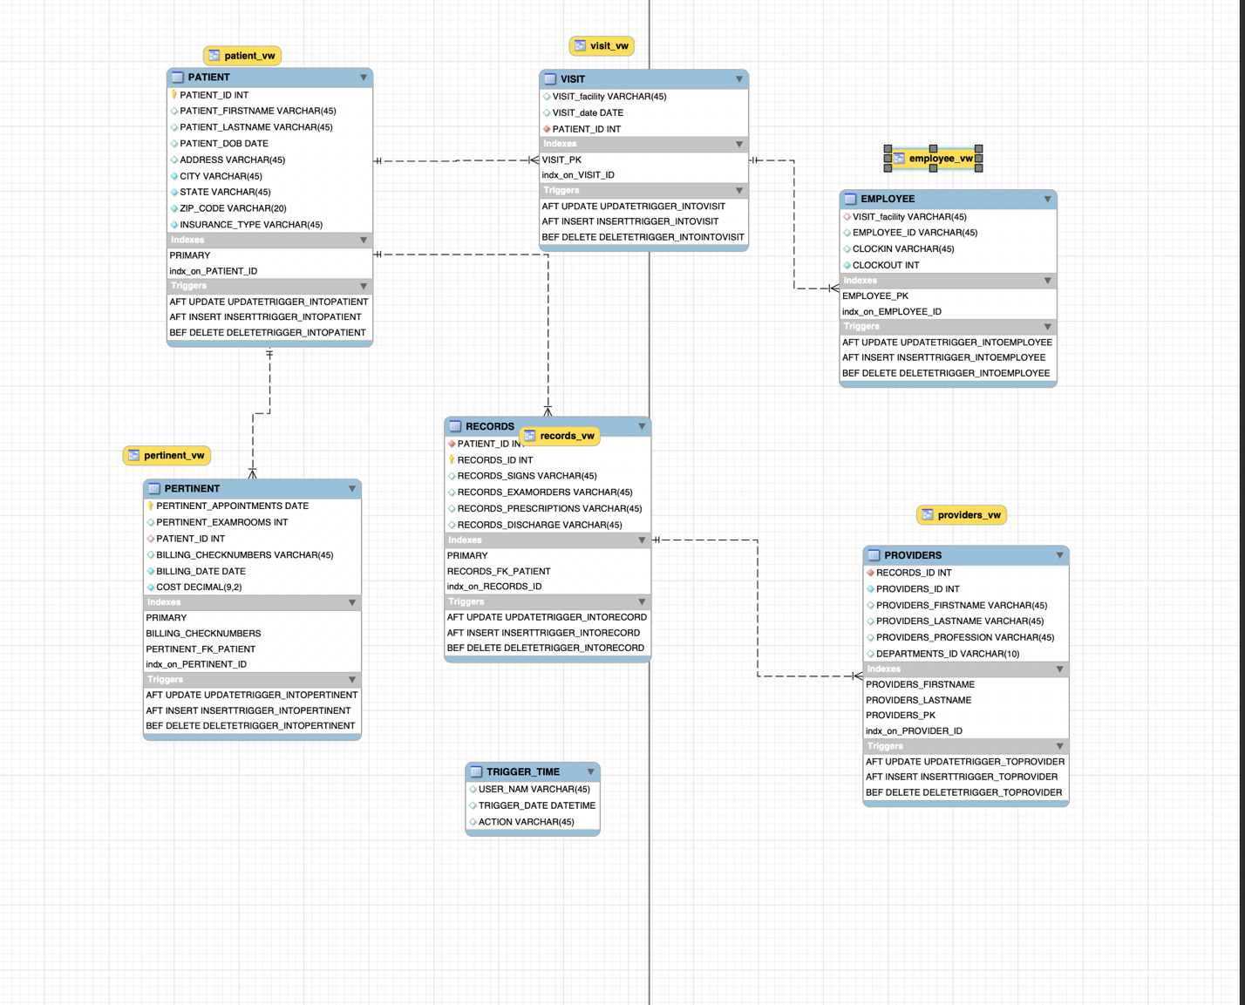

* UML Data model

